CLASS EXAMPLE: ASSIGNMENT 2

- Create a new database and save it as BOX COMPANY.
- Design the table as follows:
Field name | Data type | Size | Description
ID | Text | 3 | Customer account number
FIRST | Text | 15 | Customer first name
LAST NAME | Text | 10 | Customer last name
PHOTO | OLE |  | Customer image
GENDER | Lookup Wizard | 6 | Customer gender
PHONE | Text | 14 | Customer contact number
AMOUNT | Currency | Auto | Invoice amount
DATE | Date | Auto | Invoice date
CLIENT | Yes/No |  | Is the customer an existing client

- Select a “short date” for the date format.
- The phone field must have (999) 999-9999 typed in the “Input Mask” entry line.
- Enter the following data into the sales table.

ID | LAST NAME | FIRST NAME | PHONE | AMOUNT | DATE
004 | Reed | Les | (021) 4440123 | 243.54 | 7 October 20..
047 | Green | Cathy | (011) 5889898 | 1234.50 | 7 July 20..
023 | Sithole | Theo | (031) 6785679 | 132.76 | 24 April 20..
020 | Blue | Jan | (041) 4478902 | 452.12 | 1 November 20..
035 | Scott | Anne | (021) 5579029 | 532.21 | 8 September 20..
039 | Mbangi | Zimasa | (021) 9596222 | 1034.23 | 17 January 20..

- The clients are: 047, 020, 039, 054 and 013.
- Save the table as sales table, but add your name and surname to it.
- Add the following three records to the table:
ID | LAST NAME | FIRST NAME | PHONE | AMOUNT | DATE
054 | Fuller | Mary | (021) 8895634 | 133.40 | 17 March 20..
064 | Dell | Fiona | (011) 4601123 | 112.90 | 6 April 20..
013 | Your surname | Your name | (031) 3349080 | 450.00 | 22 January 20..
- Edit the following records by changing the amounts to:
Reed: R100.00
Sithole: R120.95
Blue: R340.00

10. QUERIES

- Create a Query called FEMALES.
10.1.1 Select the following fields: Last Name, ID, Client and Gender.
10.1.2 Display only the Female clients.

10.2 Create a Query called LAST NAME.
10.2.1 Select the following fields: First Name, Last Name and Phone.
10.2.2 Sort in Ascending order according to the Last Name.

10.3 Find the Phone numbers of 2 clients named Blue and Mbangi.
10.3.1 Select the Last Name, First and Phone fields.
10.3.2 Save the Query as BLUE & MBANGI.

10.4 Add a field called DOB to your Sales Table.
Datatype = Date/Time Format = Short date
Select your own DOB’s
10.4.1 Calculate the AGES of the Clients. Select all the fields.
10.4.2 Name the new field AGE.
10.4.4 Display the AGES without any decimals.
10.4.5 Resize your columns to ‘Best Fit’.
10.4.6 Save the Query as AGE.

10.5 Create a Query to calculate the total Sales of the Females and the total Sales of the Males.
10.5.1 Select the Gender and Amount fields.
10.5.2 Save the Query as TOTAL SALES – MALES & FEMALES.

10.6 Create a Query to calculate the Average Sales of the Males and Females.
10.6.1 Select the Gender and Amount fields.
10.6.2 Group according to the Gender field.
10.6.3 Save the Query as AVG SALES – MALES & FEMALES.

10.7 Create a Query called incl VAT. The new field should have the same name.
10.7.1 Calculate the amount to be paid inclusive of VAT (VAT = 14%)
10.7.2 Select the ID and Amount fields. Ensure that the amounts are in currency with 2 decimals.

11. FORMS

- Create a form of the Table. Switch to Design View.
- Extend the bottom of the form. Create a Tab Control.
- Draw the tab at the bottom in an open space.
- Select Properties and in the caption row type Name. Close Properties.
- By holding the control key select the following textboxes: ID, First, Last Name and DoB. R click and select cut. R click in the Name tab you created and select Paste.
- Open the 2nd tab. R click and select Properties. In the caption row capture Other Info.
- Select the following fields, cut and paste them in the Other Info tab: Phone, Amount and Date.
- Delete the Photo and Gender fields for the moment. Drag the Tabs up to line 2 to realign them.
- Select Add Existing Fields in the Tools Group in the Ribbon and double click the Photo field. Place the Photo frame in a blank space above the Tabs. Resize the frame. Do the same to the Gender field which you align to the R of the Photo.
- Create a textbox below the word Photo in which you capture =FIRST. You can delete the unnecessary box.
- Create a button in the L corner. In the wizard select Record Operations and Add New Record (see screenshot below).

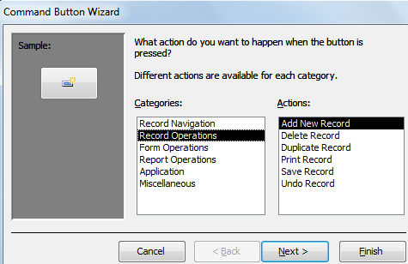

Select Next, select the text radio button and capture Add New Record and click Finish.

11.12 Create a button. This time select Record Navigation in the Categories group and Go To Next Record in the Actions Group (see screenshot below).

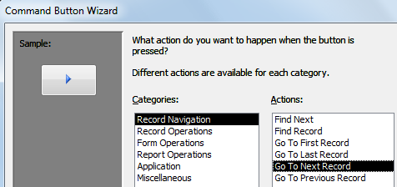
Select the Arrow.

11.13 Create buttons for the Previous Record, Deleting a Record (select a picture of a trash can) and for Printing (select the Printer picture).

11.14 Format your form attractively.

12. SWITCHBOARD

- Click the dropdown arrow in the quick access toolbar.
- Select More Commands. Under Choose Commands select More Commands. Under Choose Commands select All Commands. Add Switchboard Manager and click Ok.
- Click the Switchboard Manager and select Yes to create one. Click Edit, New. Under Command select Open Form in Edit Mode. Under Form select the Sales Table. Change the text to read Enter Customer Info, click Ok.
- Under Command select New. Select Open Report. Under Report select Sales Table. Under Text capture Customers.
- Select New. Under Command select Exit Application. Under Text capture Exit, click Ok, Close and Close.
- You will notice in the Navigation Pane that there is a form called Switchboard.
- To open the Switchboard when opening the database click File, Options, Current Database under display form select Switchboard, select Ok.
- Reopen the database to enable the changes to take effect and collapse the Navigation Pane (see screenshot).
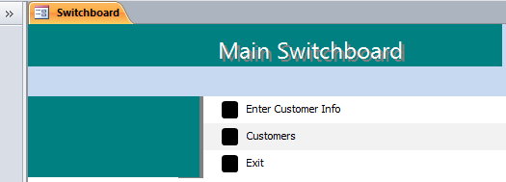
People will be faced with the Switchboard. They can access the Form, Report and Exiting the database by clicking the buttons. This will prevent anyone from changing the information in the Tables. Hint: Uncheck the navigation checkbox

